EXP 24-30
EXP-30
//exp-30
//name-sajani c
//reg.no-192412006
//dept-ECE
#include <systemc.h>
SC_MODULE(counting_semaphore) {
int sem;
void task() {
while(true) {
wait(1, SC_SEC);
if(sem > 0) {
sem--;
cout << "Task Accessing Resource at "
<< sc_time_stamp()
<< " Remaining: " << sem << endl;
wait(2, SC_SEC);
sem++;
}
}
}
SC_CTOR(counting_semaphore) {
sem = 2;
SC_THREAD(task);
SC_THREAD(task);
SC_THREAD(task);
}
};
int sc_main(int argc, char* argv[]) {
counting_semaphore obj("Counting");
sc_start(10, SC_SEC);
return 0;
}
RESULT:
[2026-10-11 13:40:35 UTC] g++ -o sim -lsystemc *.cpp && echo "Compile done. Starting run..." && ./sim
Compile done. Starting run...

SystemC 2.3.3-Accellera --- May 23 2020 14:33:56
Copyright (c) 1996-2018 by all Contributors,
ALL RIGHTS RESERVED

Warning: (W505) object already exists: Counting.task. Latter declaration will be renamed to Counting.task_0
In file: ../../../src/sysc/kernel/sc_object_manager.cpp:153

Warning: (W505) object already exists: Counting.task. Latter declaration will be renamed to Counting.task_1
In file: ../../../src/sysc/kernel/sc_object_manager.cpp:153
Task Accessing Resource at 1 s Remaining: 1
Task Accessing Resource at 1 s Remaining: 0
Task Accessing Resource at 3 s Remaining: 0
Task Accessing Resource at 4 s Remaining: 0
Task Accessing Resource at 5 s Remaining: 0
Task Accessing Resource at 6 s Remaining: 0
Task Accessing Resource at 7 s Remaining: 0
Task Accessing Resource at 8 s Remaining: 0
Task Accessing Resource at 9 s Remaining: 0
Done
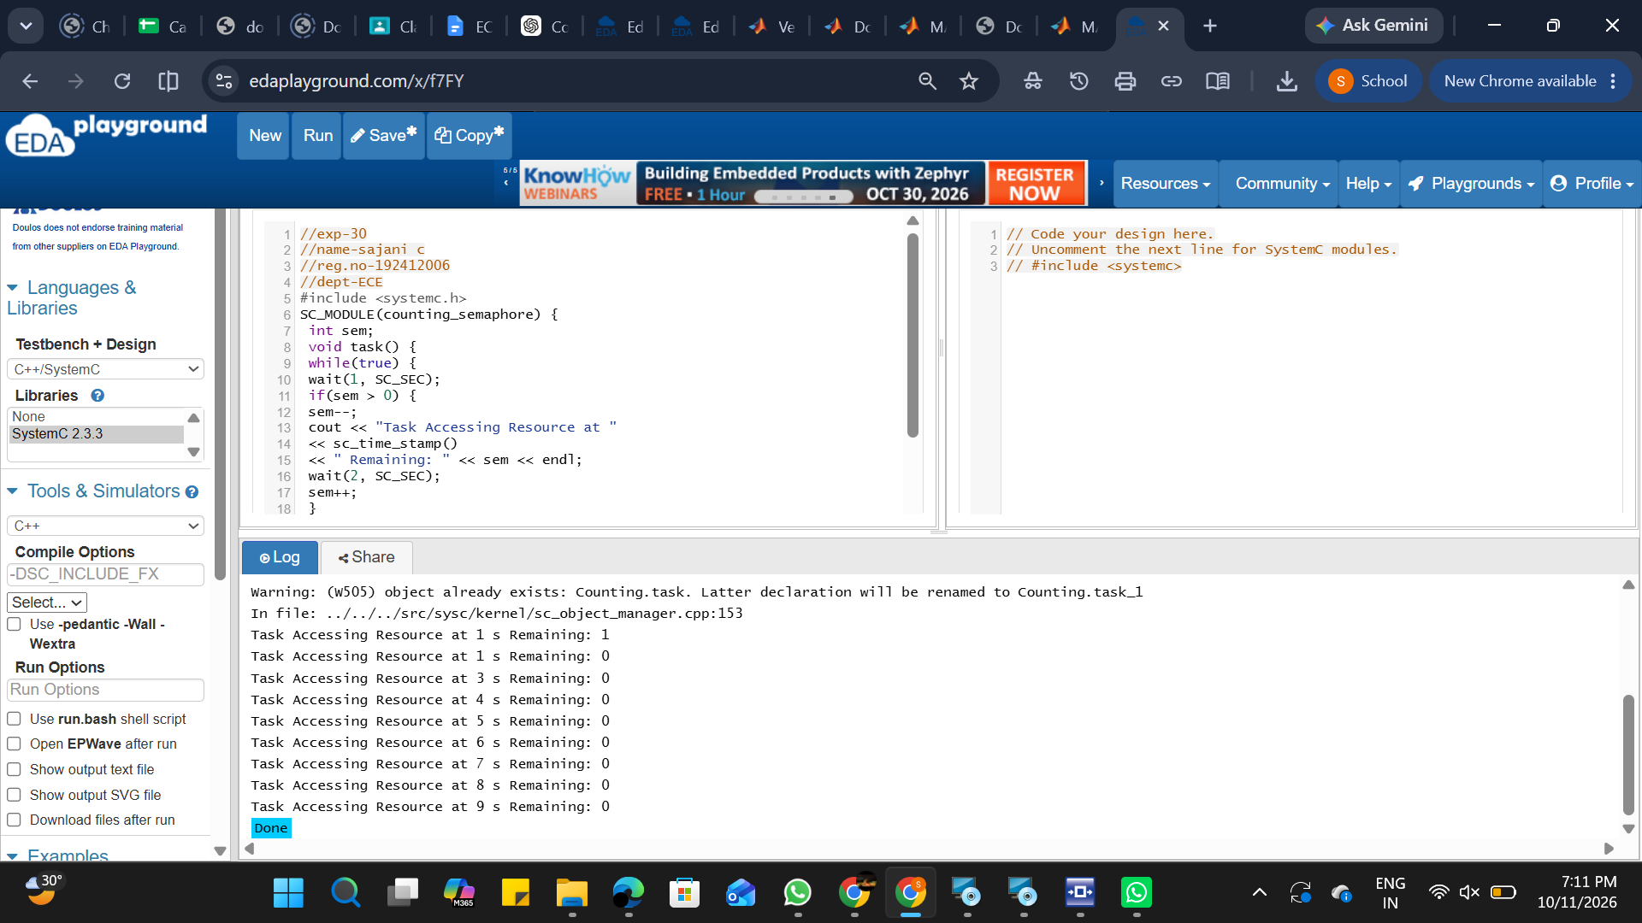
EXP-29
//exp-29
//name-sajani c
//reg.no-192412006
//dept-ECE
#include <systemc.h>

SC_MODULE(priority_interrupt) {

sc_event low_int, high_int;

void low_ISR() {
while(true) {
wait(low_int);
cout << "Low Priority Interrupt at "
<< sc_time_stamp() << endl;
wait(3, SC_SEC);
}
}

void high_ISR() {
while(true) {
wait(high_int);
cout << "High Priority Interrupt at "

<< sc_time_stamp() << endl;
wait(1, SC_SEC);
}
}

void generator() {
wait(1, SC_SEC);
low_int.notify();

wait(1, SC_SEC);
high_int.notify();
}

SC_CTOR(priority_interrupt) {
SC_THREAD(low_ISR);
SC_THREAD(high_ISR);
SC_THREAD(generator);
}
};

int sc_main(int argc, char* argv[]) {
priority_interrupt obj("Priority_INT");
sc_start(10, SC_SEC);
return 0;
}
RESULT:
[2026-10-11 13:50:28 UTC] g++ -o sim -lsystemc *.cpp && echo "Compile done. Starting run..." && ./sim
Compile done. Starting run...
SystemC 2.3.3-Accellera --- May 23 2020 14:33:56
Copyright (c) 1996-2018 by all Contributors,
ALL RIGHTS RESERVED
Low Priority Interrupt at 1 s
High Priority Interrupt at 2 s
Done
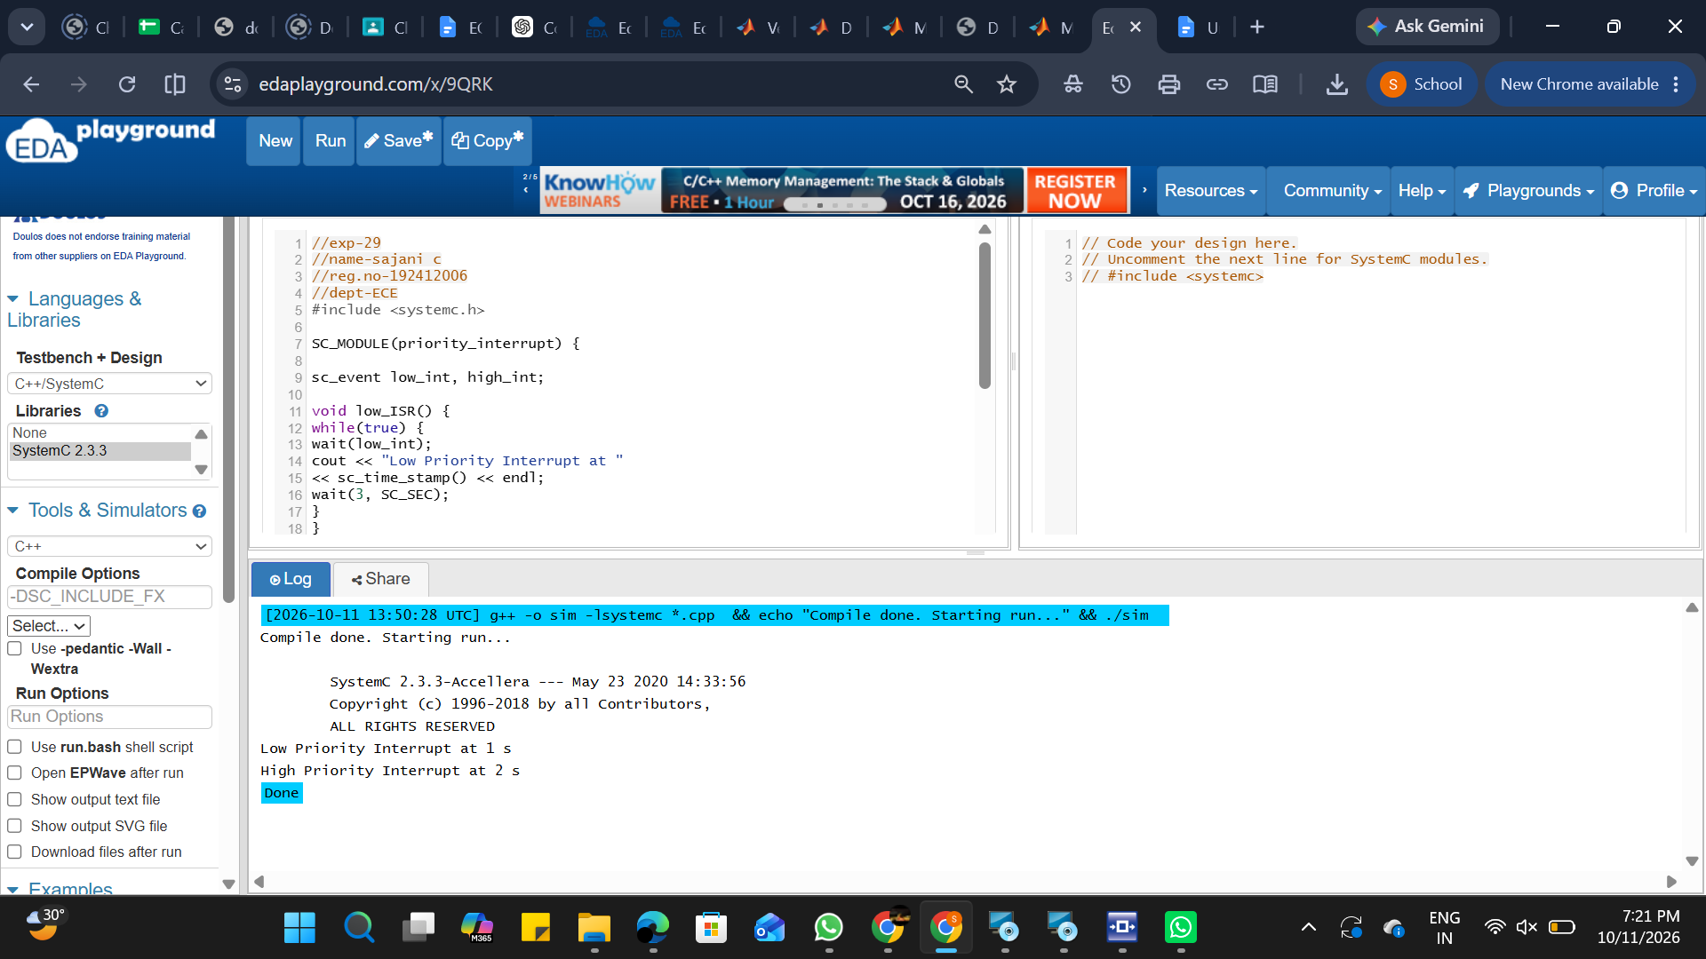
EXP-28
//exp-28
//name-sajani c
//reg.no-192412006
//dept-ECE
#include <systemc.h>
SC_MODULE(counting_semaphore) {
int sem;
void task() {
while(true) {
wait(1, SC_SEC);

if(sem > 0) {
sem--;
cout << "Task Accessing Resource at "
<< sc_time_stamp()
<< " Remaining: " << sem << endl;

wait(2, SC_SEC);
sem++;
}

}
}

SC_CTOR(counting_semaphore) {
sem = 2;
SC_THREAD(task);
SC_THREAD(task);
SC_THREAD(task);
}
};

int sc_main(int argc, char* argv[]) {
counting_semaphore obj("Counting");
sc_start(10, SC_SEC);
return 0;
}
[2026-10-11 14:05:32 UTC] g++ -o sim -lsystemc *.cpp && echo "Compile done. Starting run..." && ./sim
Compile done. Starting run...
SystemC 2.3.3-Accellera --- May 23 2020 14:33:56
Copyright (c) 1996-2018 by all Contributors,
ALL RIGHTS RESERVED

Warning: (W505) object already exists: Counting.task. Latter declaration will be renamed to Counting.task_0
In file: ../../../src/sysc/kernel/sc_object_manager.cpp:153

Warning: (W505) object already exists: Counting.task. Latter declaration will be renamed to Counting.task_1
In file: ../../../src/sysc/kernel/sc_object_manager.cpp:153
Task Accessing Resource at 1 s Remaining: 1
Task Accessing Resource at 1 s Remaining: 0
Task Accessing Resource at 3 s Remaining: 0
Task Accessing Resource at 4 s Remaining: 0
Task Accessing Resource at 5 s Remaining: 0
Task Accessing Resource at 6 s Remaining: 0
Task Accessing Resource at 7 s Remaining: 0
Task Accessing Resource at 8 s Remaining: 0
Task Accessing Resource at 9 s Remaining: 0
Done
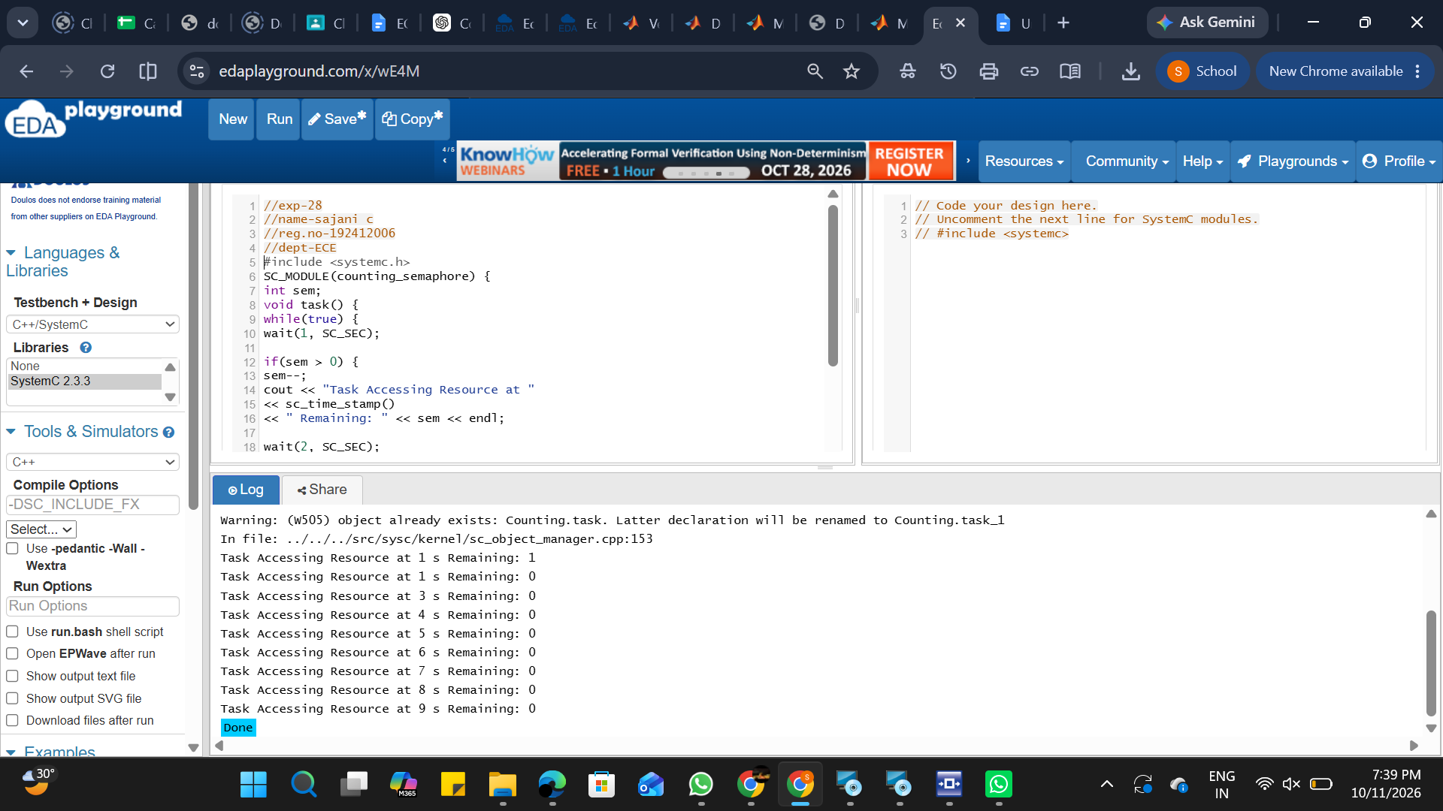
EXP-27
//exp-27
//name-sajani c
//reg.no-192412006
//dept-ECE
#include <systemc.h>
SC_MODULE(binary_semaphore) {
int sem;
sc_event ev;
void task1() {
while(true) {
wait(1, SC_SEC);

if(sem == 1) {

sem = 0;
cout << "Task1 Entered Critical Section at " << sc_time_stamp() << endl;
wait(2, SC_SEC);
sem = 1;
ev.notify();
}
else {
wait(ev);
}
}
}

void task2() {
while(true) {
wait(2, SC_SEC);

if(sem == 1) {
sem = 0;
cout << "Task2 Entered Critical Section at " << sc_time_stamp() << endl;
wait(1, SC_SEC);
sem = 1;
ev.notify();
}
else {
wait(ev);
}
}
}

SC_CTOR(binary_semaphore) {
sem = 1;
SC_THREAD(task1);
SC_THREAD(task2);
}

};

int sc_main(int argc, char* argv[]) {
binary_semaphore obj("Binary_Semaphore");
sc_start(10, SC_SEC);
return 0;
}
[2026-10-11 14:13:29 UTC] g++ -o sim -lsystemc *.cpp && echo "Compile done. Starting run..." && ./sim
Compile done. Starting run...

SystemC 2.3.3-Accellera --- May 23 2020 14:33:56
Copyright (c) 1996-2018 by all Contributors,
ALL RIGHTS RESERVED
Task1 Entered Critical Section at 1 s
Task1 Entered Critical Section at 4 s
Task1 Entered Critical Section at 7 s
Done
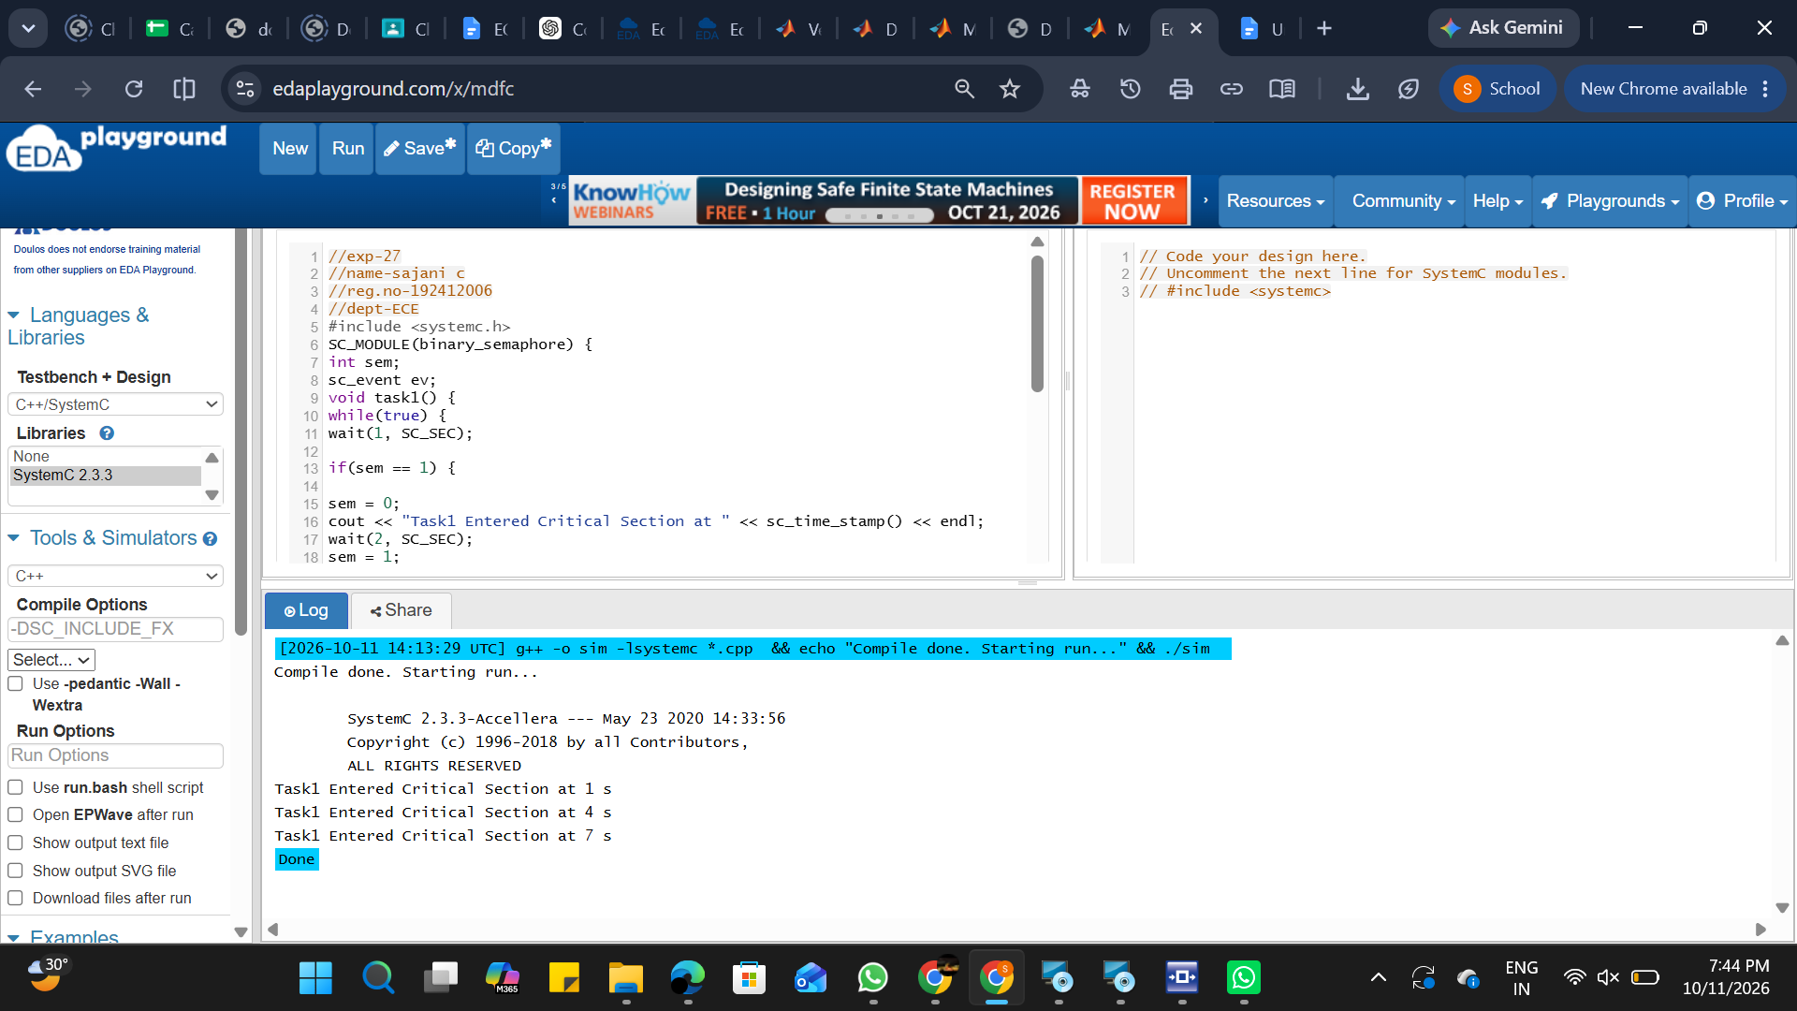
EXP-26
//exp-26
//name-sajani c
//reg.no-192412006
//dept-ECE
#include <systemc>
#include <tlm>
#include <tlm_utils/simple_initiator_socket.h>
#include <tlm_utils/simple_target_socket.h>

using namespace sc_core;
using namespace tlm;
using namespace std;

// Target
struct Target : sc_module {
tlm_utils::simple_target_socket<Target> socket;

SC_CTOR(Target) : socket("socket") {
socket.register_b_transport(this, &Target::b_transport);
}

void b_transport(tlm_generic_payload& trans, sc_time& delay) {
int* data = (int*) trans.get_data_ptr();
cout << "Target received: " << *data << endl;

delay += sc_time(10, SC_NS);
}
};

// Initiator
struct Initiator : sc_module {
tlm_utils::simple_initiator_socket<Initiator> socket;

SC_CTOR(Initiator) : socket("socket") {
SC_THREAD(thread_process);
}

void thread_process() {
tlm_generic_payload trans;
sc_time delay = SC_ZERO_TIME;

int data = 555;

trans.set_data_ptr(reinterpret_cast<unsigned char*>(&data));
trans.set_data_length(sizeof(data));

cout << "Initiator sending: " << data << endl;
socket->b_transport(trans, delay);

wait(delay);
}
};

int sc_main(int argc, char* argv[]) {

Initiator initiator("initiator");
Target target("target");

initiator.socket.bind(target.socket);

sc_start();

return 0;
}
[2026-10-11 14:18:32 UTC] g++ -o sim -lsystemc *.cpp && echo "Compile done. Starting run..." && ./sim
Compile done. Starting run...

SystemC 2.3.3-Accellera --- May 23 2020 14:33:56
Copyright (c) 1996-2018 by all Contributors,
ALL RIGHTS RESERVED
Initiator sending: 555
Target received: 555
Done
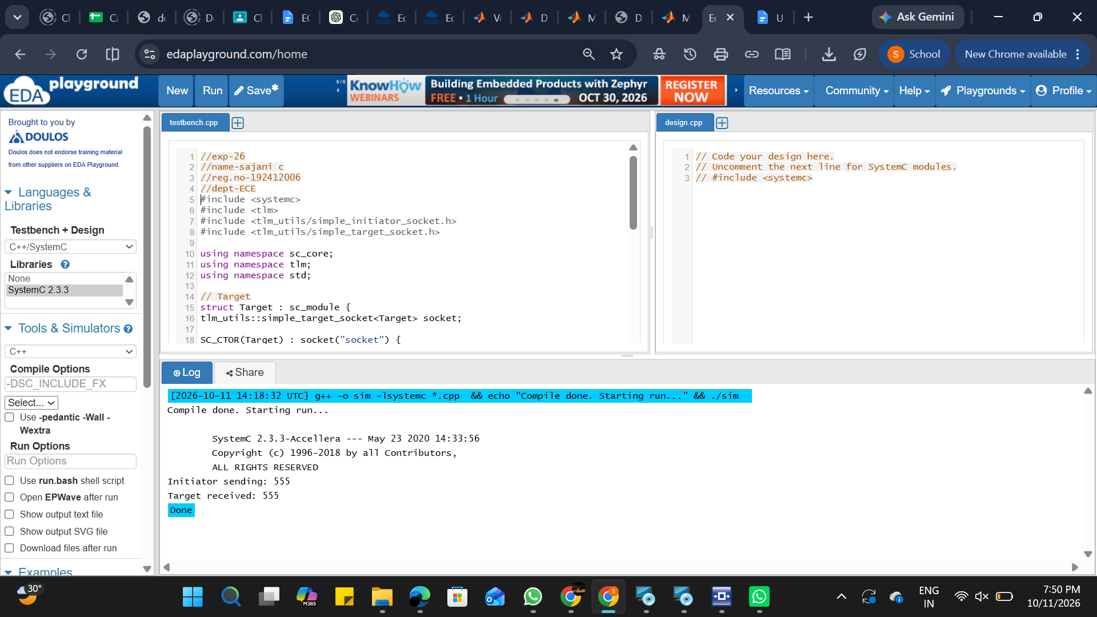
EXP-25
//exp-25
//name-sajani c
//reg.no-192412006
//dept-ECE
#include <systemc.h>

// Producer Module
SC_MODULE(Producer) {
sc_fifo_out<int> out;

void produce() {
for (int i = 1; i <= 5; i++) {
cout << "Produced: " << i << endl;
out.write(i);
wait(1, SC_SEC);

}
}

SC_CTOR(Producer) {
SC_THREAD(produce);
}
};

// Consumer Module
SC_MODULE(Consumer) {
sc_fifo_in<int> in;

void consume() {
int value;
while (true) {
in.read(value);
cout << "Consumed: " << value << endl;
wait(1, SC_SEC);
}
}

SC_CTOR(Consumer) {
SC_THREAD(consume);
}
};

int sc_main(int argc, char* argv[]) {
sc_fifo<int> fifo(5);

Producer producer("Producer");
Consumer consumer("Consumer");

producer.out(fifo);
consumer.in(fifo);

sc_start(10, SC_SEC);

return 0;
}
[2026-10-11 14:23:30 UTC] g++ -o sim -lsystemc *.cpp && echo "Compile done. Starting run..." && ./sim
Compile done. Starting run...

SystemC 2.3.3-Accellera --- May 23 2020 14:33:56
Copyright (c) 1996-2018 by all Contributors,
ALL RIGHTS RESERVED
Produced: 1
Consumed: 1
Produced: 2
Consumed: 2
Produced: 3
Consumed: 3
Produced: 4
Consumed: 4
Produced: 5
Consumed: 5
Done
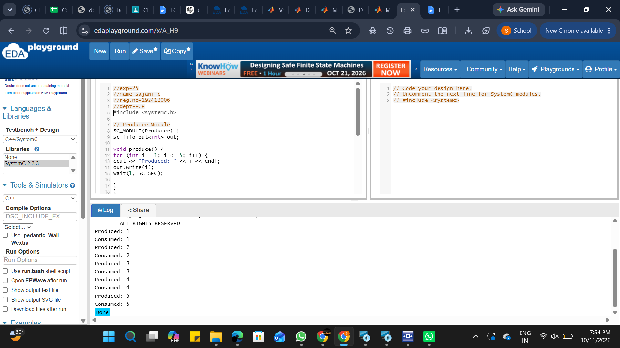

EXP-24
//EXP-24
//name-sajani c
//reg.no-192412006
//dept-ECE
#include <systemc.h>

SC_MODULE(ClockExample) {
sc_in<bool> clk;

void process() {
while (true) {
wait();
std::cout << "Time: " << sc_time_stamp()
<< " - Clock Triggered" << std::endl;
}
}

SC_CTOR(ClockExample) {
SC_THREAD(process);
sensitive << clk.pos();

}
};

int sc_main(int argc, char* argv[]) {

sc_clock clock("clock", 1, SC_NS);

ClockExample module("module");
module.clk(clock);

sc_start(5, SC_NS);

return 0;
}
[2026-10-11 14:27:08 UTC] g++ -o sim -lsystemc *.cpp && echo "Compile done. Starting run..." && ./sim
Compile done. Starting run...

SystemC 2.3.3-Accellera --- May 23 2020 14:33:56
Copyright (c) 1996-2018 by all Contributors,
ALL RIGHTS RESERVED
Time: 0 s - Clock Triggered
Time: 1 ns - Clock Triggered
Time: 2 ns - Clock Triggered
Time: 3 ns - Clock Triggered
Time: 4 ns - Clock Triggered
Done
